Application Domain: <https://doodlesapp.herokuapp.com/>

I used Heroku git, through Heroku CLI, for deploying my java project.

I followed all the slide steps (Spring Boot for Spring based Application, maven 3.5, Heroku account) but I found some troubles during the “building” of the project.

Heroku didn’t allow me to deploy the application for an absent jar reference (probably an artifact that Spring wasn’t able to build). Here, what I carried out for resolving the issues found:

* Uninstalled Java 7 and 8, maven and IntelliJ. After that, I re-installed everything;
* Imported Spring Boot Project in a maven project using IntelliJ IDE;
* Implemented DoodleController class;
* Added File doodle.jar to target (manually!);
* Configured Maven compilator with “*Resolve Workspace artifacts*”;
* Created Procfile with *“web: java -jar -Dserver.port=$PORT target/doodle-0.0.1-SNAPSHOT.jar”* inside;
* Moved into the folder of my doodle project;
* *‘git init’* (only the first time) *-> ‘git add .’ -> ‘git commit -m “commit 1”’*
* *‘heroku login’ -> ‘heroku create doodlesapp’* (only the first time) *->* *‘heroku git:remote -a doodlesapp’ -> ‘git push heroku master’* (Issue created by this instruction)
* *‘Mvn clean install -DskipTests’*

After these operations, Java Project was correctly deployed and Heroku compiled without any issue. On localhost, after the command *‘heroku local web’*, the application went rightly up. Nevertheless, if I did a GET to the application domain, something went wrong, the service was still down.

Only after

* *‘heroku ps:scale web=1’* and
* ‘heroku config:set WEBAPP_RUNNER_OPTS="-Dspring.profiles.active=test" --app doodlesapp’

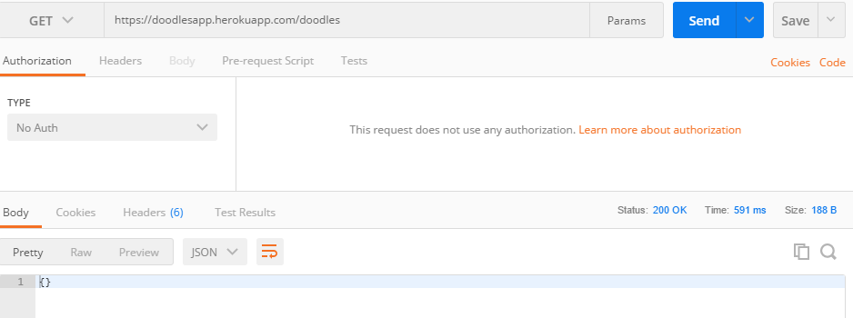

Service went correctly up.

**TESTS**

First PUT /doodles (returns id created) and then GET /doodles: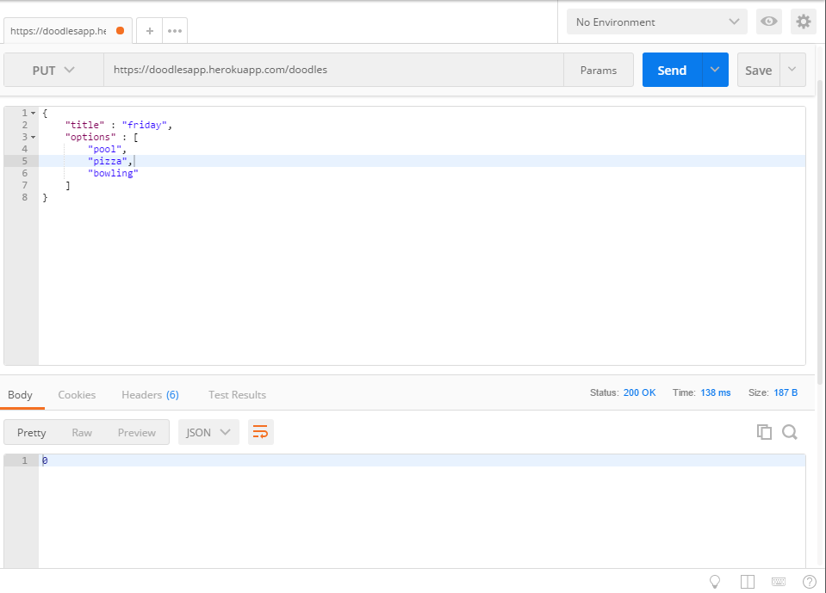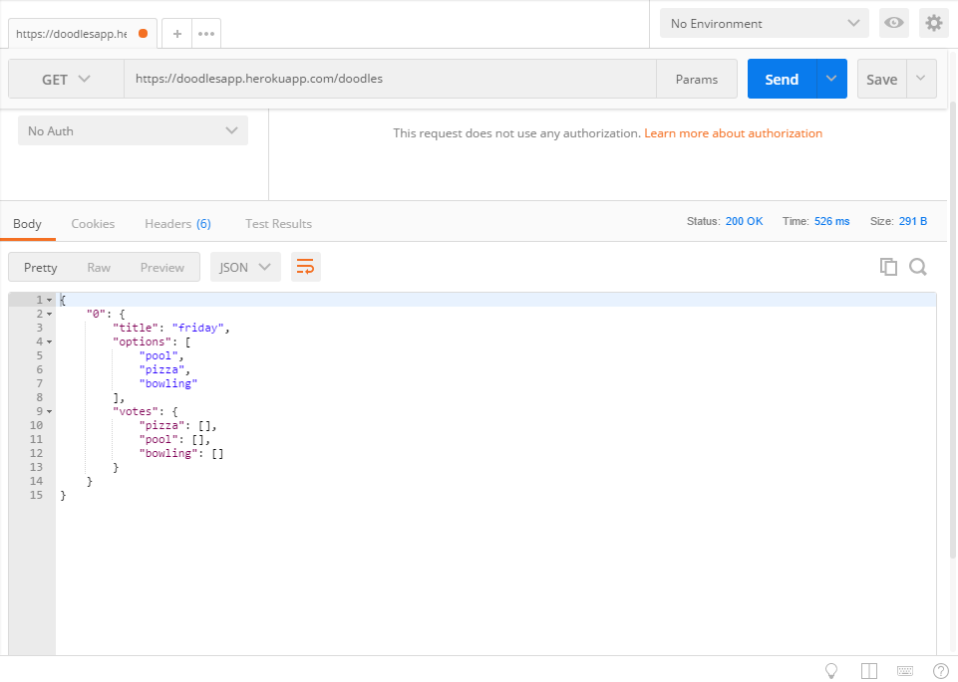

PUT first vote, with “lorenzo” as voter, for “bowling”, then some others. It returns the name of the voter.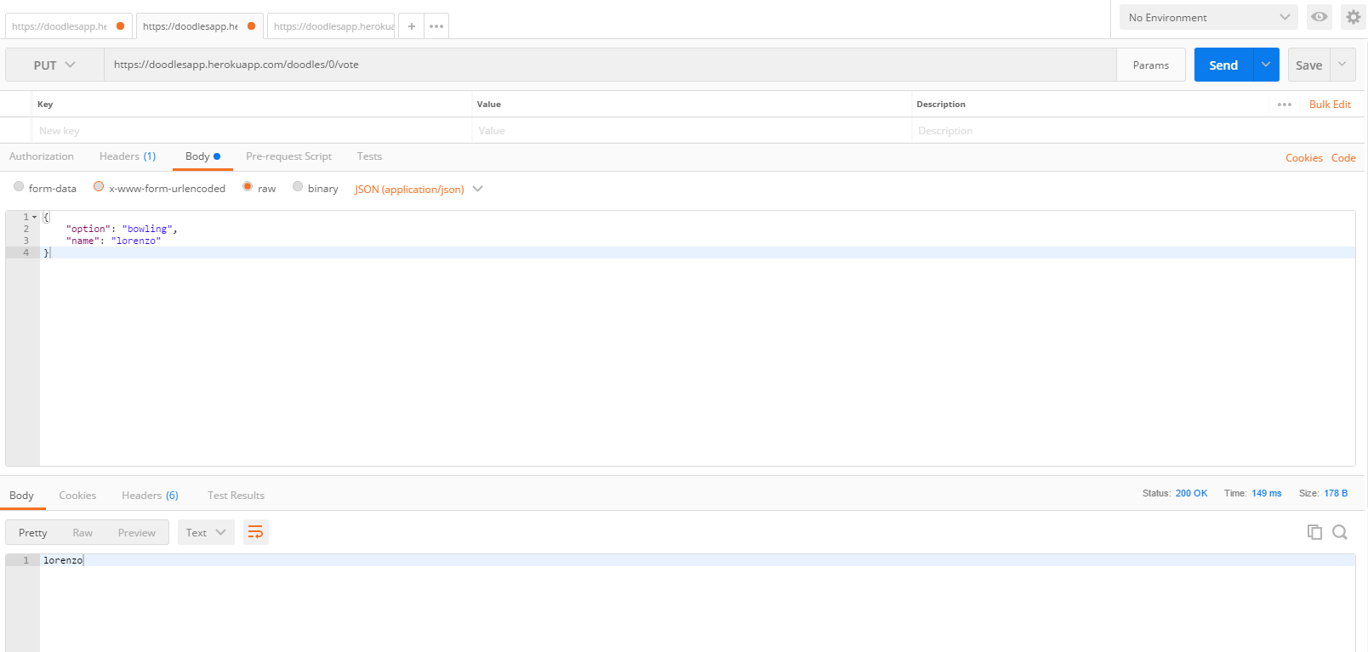

GET <https://doodlesapp.herokuapp.com/doodles/0> (with id=0)

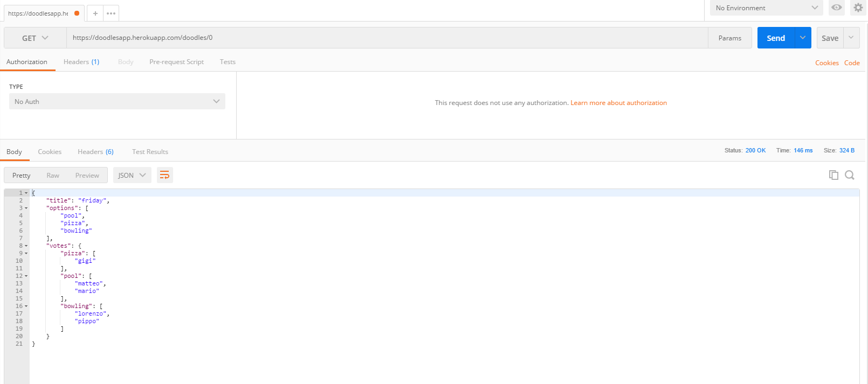

DELETE id=0C:\Users\User\AppData\Local\Microsoft\Windows\INetCache\Content.Word\DELETE id.png

PUT the same (now the id is 1!)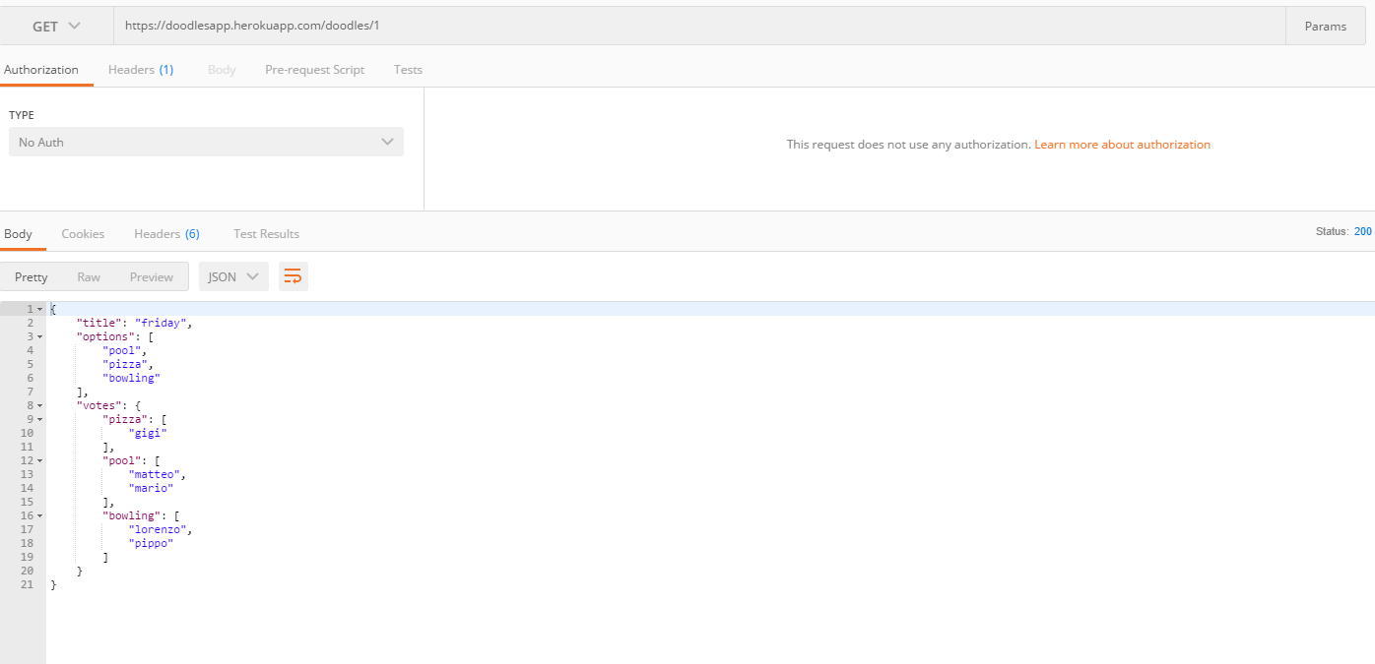

Deleted “matteo” and GET id=1 again: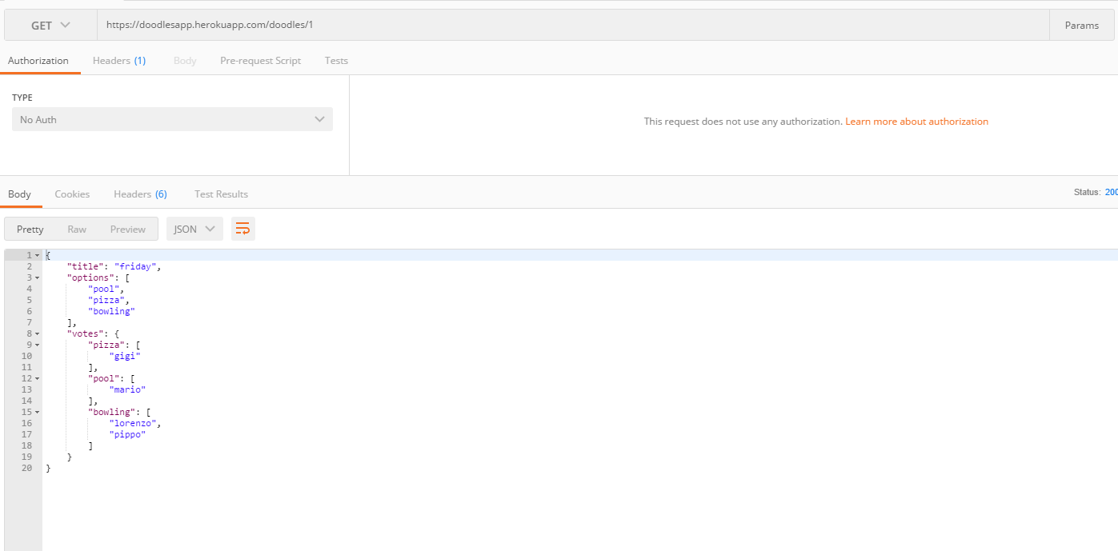

GET id=1 with “lorenzo” as name

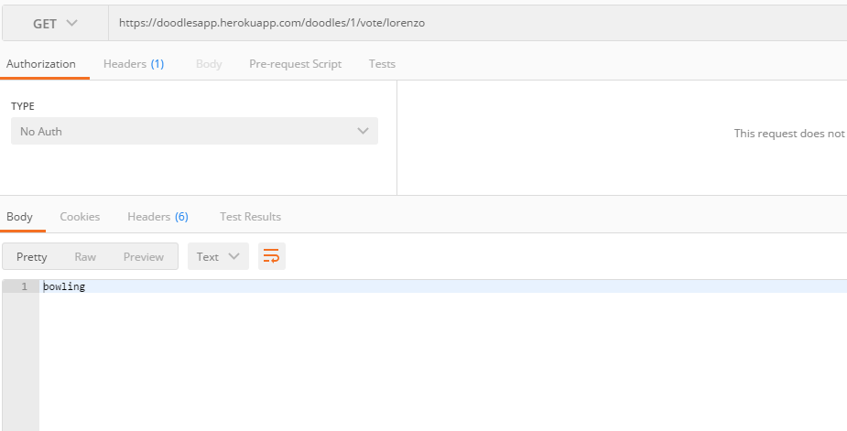

POST with “lorenzo” as name (with names that aren’t contained in votes, it’s return a blank string):

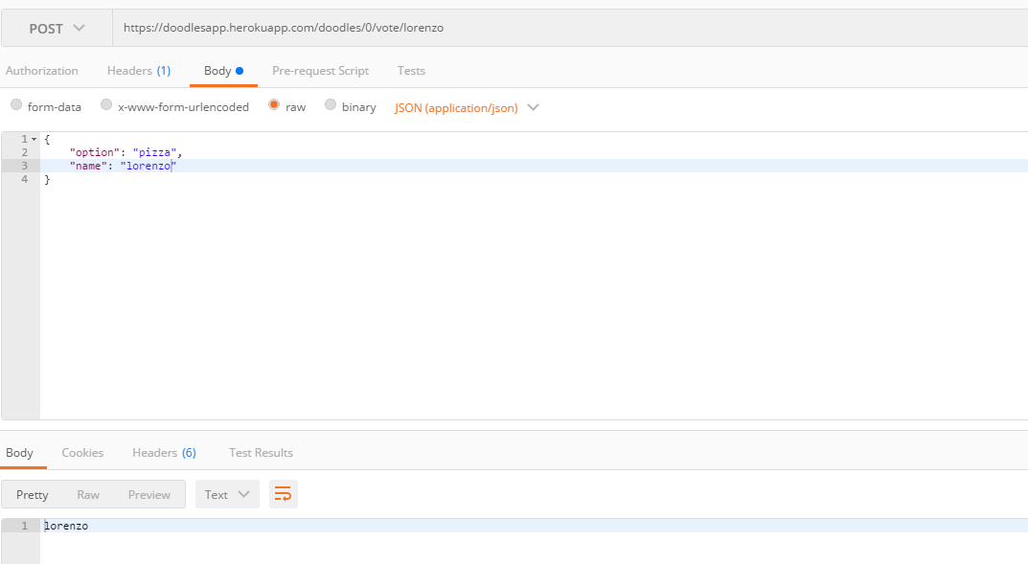

And last one GET:

